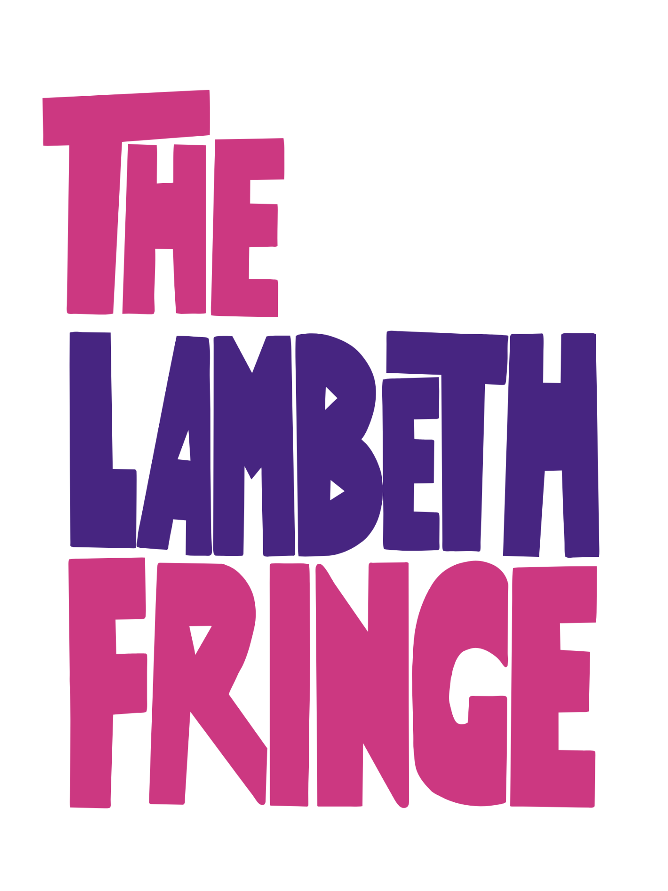

Before you begin.
- Read through all the questions and decide which ones you are going to answer. Don't answer everything!
- Choose your "Core Questions": Consider answering both questions in Section 1, then pick possibly four further questions that you feel most passionate about from Sections 2, 3 and 4. This allows you to give deeper, more meaningful answers rather than rushing through several. Then finish it all off with a couple of the quick fire silly questions in the last section.
- Watch the word count: Aim for a total between 600 and 1,000 words across the whole form to ensure we have enough "meat" for a full feature. Too short and you’re risking people feeling your show would be the same and lacking in much depth, too long and people will simply give up reading.
- Use this sheet to prepare your responses, take your time to think about what you want to say and how best to promote your show. There are no prizes for being the first to return your completed Q&A.
- When you’re ready simply copy and paste your responses into the online form.
- Provide as many images as you have so we can use as many as appropriate for your Q&A.
If you have any questions, please email interviews@everything-theatre.co.uk

Section 1: General information

You’ll need to provide some basic details just so we know what to include in the introduction to your interview.

- Your name
- Contact email (in case there are any issues and we need to get in touch)
- Company name, if you have one.
- Who else, if anyone, is answering with you?
  - Give us everyone’s full names so we can name check everyone in the introduction.
  - If more than one person is answering, you can either do so as a group, or take turns to respond to different questions, or even the same one. If you are doing this option, make sure you add your first name against each response so we can include this when publishing.
- Show title
- Venue: If multiple venues, add them all and we’ll make sure to include all the details.
- First performance date: We try to publish our interviews in rough order of when shows are playing.
- Booking link
- Your website link if you have one
- Social media handles (Instagram only) so we can mention you when we post the interview over our channel.

Section 2: Payment
As much as we would love to do all this for free, it’s just not possible.. But we like to think our fees are reasonable and appropriate for the exposure you will receive by being published on our website and over our social media channels.

For this year’s Lambeth Fringe the fees are:
- Q&A plus one promotional post to Instagram and Facebook: £15
- Q&A, plus five posts to Instagram and two to Facebook: £35
10% of all income will be deposited into our ET Creative Kitty. This is a growing pot of money we will award as a prize during our Etties Live event on 21 February next year. You can read more about this here.

We accept the following payment methods.

- Direct bank transfer (preferred option)
Sort code: 60-83-71
A/c No: 58263933
A/c Name: Robert Warren (Trading as Everything Theatre)< for most banks it will only require/ recognise Robert Warren as the account name.
- Kofi via https://ko-fi.com/everythingtheatre.
- Paypal to robwarren70@googlemail.com
………………………………………………………….

Section 3: Opening Questions
(We recommend answering both of these as a way to just set the scene.)

- If you had to describe the vibe of your show in just one sentence, what would it be and how does it manifest on stage?
- Why is 2026 the perfect time for this show to be seen?

…………………………………………………………..

Section 4: Questions for the writer if answering
(Feel free to answer any or none of these)

- What was the 'eureka moment' that made you realise this story had to be told right now?
- Is this version how you originally envisioned it or has it changed drastically since you first put pen to paper?
- What is something a performer has brought to a character that completely surprised you?
………………………………………………………..

Section 5: Questions for performers if answering
(answer any or none of these)

- What was it that drew you to this show and role?
- What is it about your character that you most enjoy?
- How challenging has this role been for you?
………………………………………………………..

Section 6: General questions for anyone
(we’d recommend just one or possibly two of these)

- What is the "secret sauce" that makes your group dynamic work?
- Being a festival festival, we all know sets have to be bare minimum, how have you worked around this requirement?
- What has been the biggest challenge in realising the writer’s vision for the show?
- How important is audience interaction to you?
- Are there any plans for what comes next after the show has finished its run – for you or the show?
- What does "success" look like for you, beyond just selling tickets?
………………………………………………..

Section 7: Some silly questions
(We suggest answering two or three of these, and think about answers that are short and snappy, one or two sentences at most, but not just one word! Tell us why you’ve given your responses, and how that relates to your show)

- Who would play you in the Hollywood adaptation of your life?
- If your show was a colour what would it be, and why?
- If your show was a meal what would it be?
- What songs would make up the soundtrack to your show?
- If you could perform this show anywhere in the world, where would it be and why?
- If your show was a love letter to a specific person, place, or era, who or what would it be?
- If your show was a drink at the venue bar, what would be the ingredients?
- What’s the weirdest or most unconventional prop used in your show, and how did it come to be part of the production?
- If budget or reality was not an issue, what’s the one thing you’d love to have in your show?
- Write a one-sentence "fake" review of the show (Maybe from your gran, a teacher, your pet, or just some random person. Don't forget to add in your fake review who it is from!)
- What’s the most valuable piece of advice you’ve received during your career, and how has it influenced this show?
- What words of advice/encouragement would you give anyone thinking about doing Lambeth Fringe next year?
- Is there a question missing that you feel we should be asking you? (and feel free to answer it as well, we’ve found these can be really interesting ways to end the interview)

……………………………………………………….

Section 8: Images

You can upload your images here. We require at least one image, and one should ideally be landscape which will be the header image for the published Q&A. If you have additional images, please do provide those and we will add as many as suitable into the body of the interview.

………………………………………………………..

